Part II (1) Interview (3 minutes)
Now you’ll see an advertisement.



Task:
- Suppose you’re a waiter/waitress at the bakery and you are explaining to a customer what the opening is like. You will answer questions from the customer.
[Contestant: A waiter/waitress at the bakery
Question Master: A customer

Part II (2) Interview (3 minutes)
Now you’ll see a flyer (传单).


Task:
- Suppose you’re a volunteer at the Students’ Union and you are answering a phone call from somebody who’s interested in the event. You will answer questions from the caller.
[Contestant: A volunteer at the Students’ Union
Question Master: An interested caller

Part II (3) Interview (3 minutes)
Now you’ll see an advertisement for a first aid course.

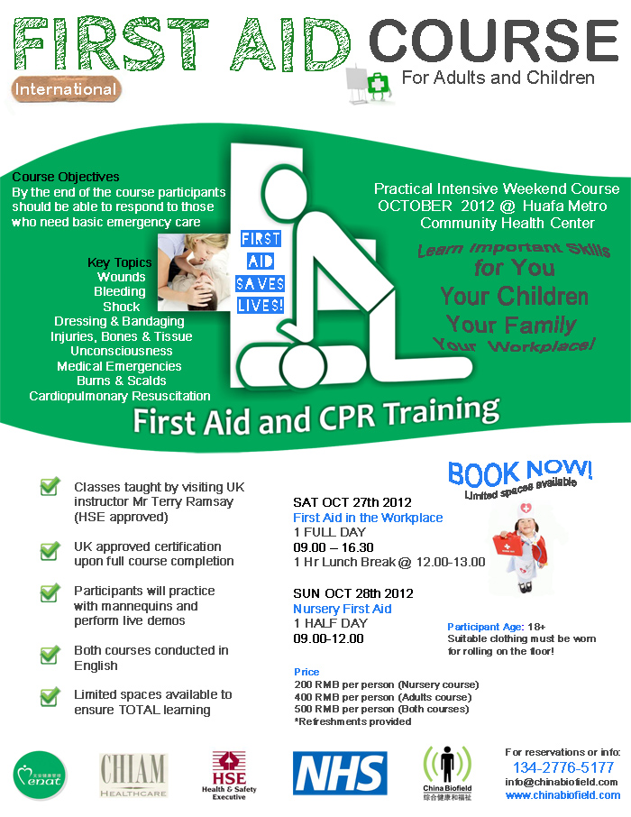
Task:
Suppose you’re one of the organizers of the first aid course and you are talking with a person who is interested in the course. You will answer questions from the person.
[Contestant: An organizer of the first aid course
Question Master: A person who is interested in the course

Part II (4) Interview (3 minutes)
Now you’ll see a job fair advertisement.



Task:
Suppose you’re one of the organizers of the job fair and you are talking with a person who is interested in the job fair. You will answer questions from the person.
[Contestant: An organizer of the job fair
Question Master: A person who is interested in the job fair

Part II (5) Interview (3 minutes)

Now you see a poster on language learning
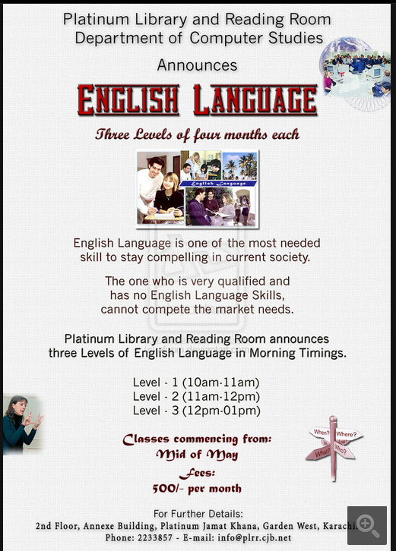

Task:
- Suppose you are the organizer of this course.
- A student comes to ask you for information about this course. Be prepared to answer his or her questions.
Part II(6) Interview (3 minutes)

Now you see an owner’s manual of a product.

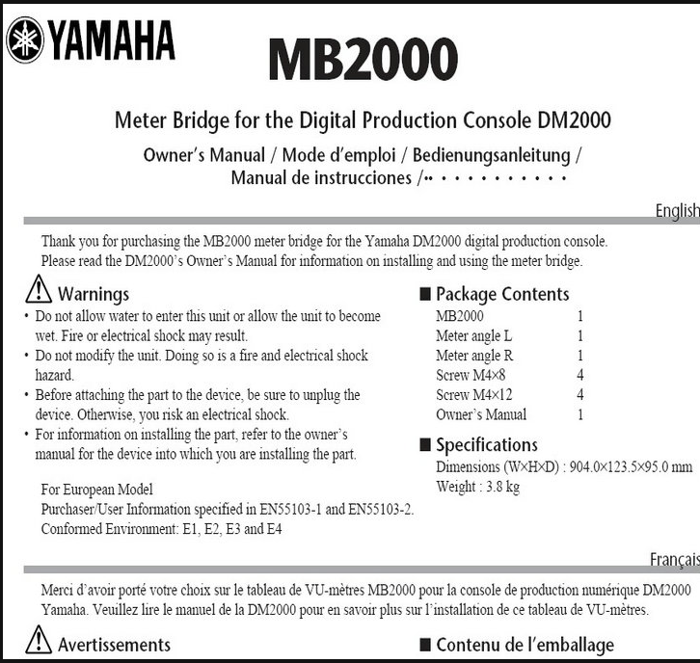
Task:
- Suppose you are a salesman.
- A customer comes to ask you for information about this product. Be prepared to answer his or her questions.

Part II (7) Interview (3 minutes)
Now you’ll see an advertisement.



Task:
- Suppose you’re a salesperson working for the dealer and you are explaining to a customer what the summer sales will be like. You will answer questions from the customer.
[Contestant: A salesperson
Question Master: A customer

Part II (8) Interview (3 minutes)
Task: You are required to talk about specifications of an alcohol breath analyzer. Suppose you are a salesperson. Prepare to answer a customer’s questions on it.

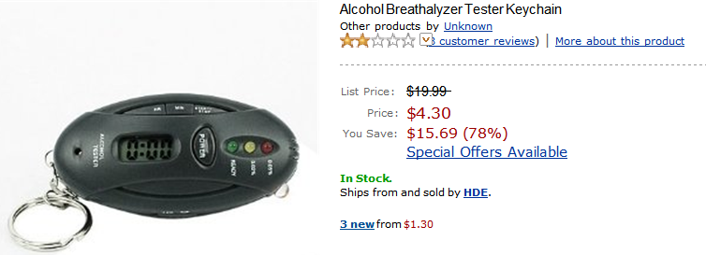

Special Offers and Product Promotions
- Save $5.00 when you spend $50.00 or more on Your Order. Enter code HDESHOP4 at checkout.

Technical Details
- A simple method to analyze blood alcohol concentration anytime & anywhere
- Portable & convenient to carry on keychain
- 5 in 1, include Timer, LED Light

Product Details
- Product Dimensions: 12 x 9 x 0.1 inches ; 8 ounces
- Shipping Weight: 3 pounds
- Average Customer Review: 2.1 out of 5 stars
- Date first available at Amazon.com: November 25, 2008

Contestant: A salesperson
Question Master: A customer

Part II (9) Interview (3 minutes)
Now you see an advertisement.

Reception Clerk
Xinhua Hotel , the only five-star hotel in Binhai City
now seeking for two female reception clerks Qualifications and conditions:
    - Girl (23—28 years old).
    - Hard working
    - College diploma
    - Good at spoken English and Japanese
    - Having good command of computer skills
    - Having at least two-year related job experience
    - Beautiful appearance, graceful manner and warm attitude
    - Excellent benefits will be provided
Please send your resume to: Lili, Personnel Department, Xinhua Hotel
Address: 18 Binhai North Road, Binhai City
Post Code: 343130
Email to: xxhhpl@126.com

Task:
- Suppose you are the personnel manager.
- An applicant is coming to ask for some information about the advertisement. Please get ready to answer her/ his questions.

Part II (10) Interview (3 minutes)
Now you’ll see an advertisement.



Task:
- Suppose you’re an agent at a rental agency and you are answering a phone call from a customer. You will answer questions from the customer.
[Contestant: An agent at a rental agency
Question Master: A customer

